**Week 7**

# **TASK 2:**

The resources created are as follows:

**Azure Resource Group:**

An Azure Resource Group serves as a convenient container for organizing and managing interconnected Azure resources. It simplifies the process of deploying, monitoring, and administering resources by providing a logical grouping mechanism.

**Azure Virtual Network (VNet):**

An Azure Virtual Network creates an isolated network environment within Azure. It enables secure connectivity and management of Azure resources, such as virtual machines, allowing them to communicate with each other and with on-premises networks.

**Azure Virtual Machine is a flexible Azure Virtual Machine (VM):**

le and scalable computing resource that operates in the cloud. It functions like a virtualized computer system, capable of running an operating system and applications. It serves various purposes, including hosting websites and running software applications.

**Azure Storage Account:**

Azure Storage Account is a reliable and scalable cloud storage solution offered by Azure. It enables the storage and retrieval of different types of data, such as files, blobs, tables, and queues, from anywhere and at any time.

**Azure Network Security Group (NSG):**

Azure Network Security Group acts as a firewall, controlling network traffic and managing access to Azure resources. It allows the creation of inbound and outbound security rules to regulate specific network traffic based on protocols, ports, source/destination IP addresses, and other parameters.

**Azure Virtual Network Gateway:**

Azure Virtual Network Gateway is a networking component that establishes secure connections between Azure virtual networks and on-premises networks. It facilitates the creation of VPN or ExpressRoute connections, ensuring secure communication between resources located on-premises and in Azure.

# **TASK 3:**

Perform the following actions after completing the module to set up a virtual machine:

* Try to access your website: Initially, you may encounter a connection timed out error when attempting to visit the website.
* Add a rule to the Network Security Group (NSG) for HTTP access through the Azure Portal:
* Navigate to the Azure Portal and select "View all resources" to see all resources.
* Locate the Network Security Group (NSG) associated with your virtual machine.
* Go to the Inbound Security Rules section.
* Click "Add" on the toolbar and choose HTTP as the service to be added.
* Verify that the new rule allowing HTTP (port 80) access has been successfully implemented.
* Retry accessing your website: After configuring the HTTP rule, try accessing your website again. It should now be available and accessible.

Login to the Ubuntu VM using SSH and modify the web page:

Use the following command to log in to the Ubuntu VM using the Cloud Shell or an SSH client:

**ssh -l azureuser IPADDRESS**

Replace IPADDRESS with the public IP address of your Ubuntu Virtual Machine.

After logging in, run the following command to modify the website:

**sudo nano /var/www/html/index.html**

Add your name to the HTML code, press Ctrl+O to save the changes, and then Ctrl+X to close the editor.

Visit the webpage again: Refresh the webpage to view the changes you made. You should now see your name displayed on the page.

**Journal Tasks:**

In your diary, include the Azure CLI instructions used to set up Nginx and create the VM.

Take note of your VM's public IP address.

Capture a screenshot in your diary showing your web browser successfully accessing the website and displaying your name on the page.

Provide the port number and describe the two network security rules that allow access to your VM, including the permitted apps or protocols for each rule.

# **TASK 4 and 5:**

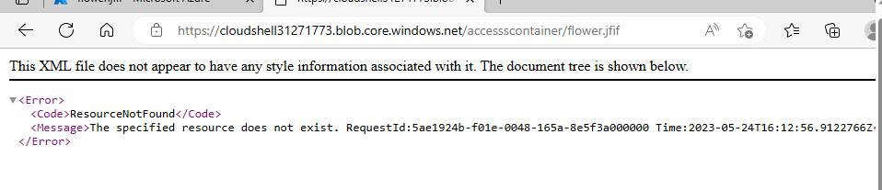

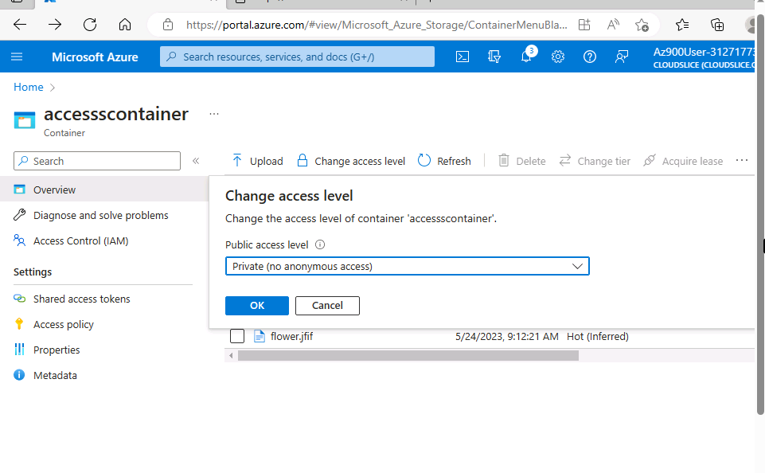

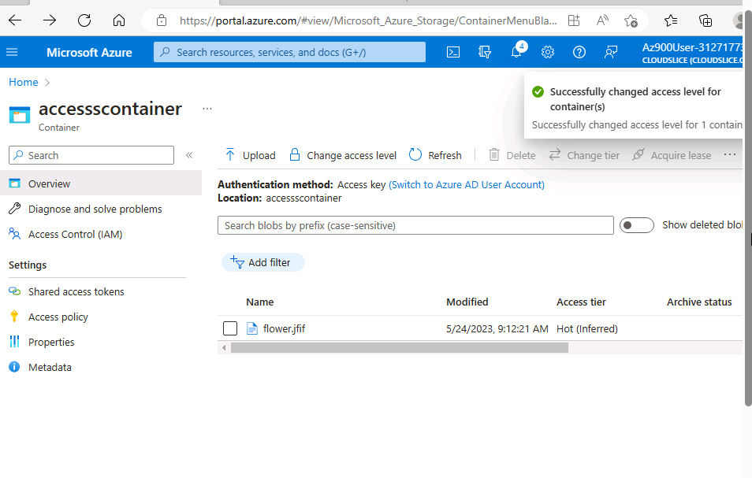

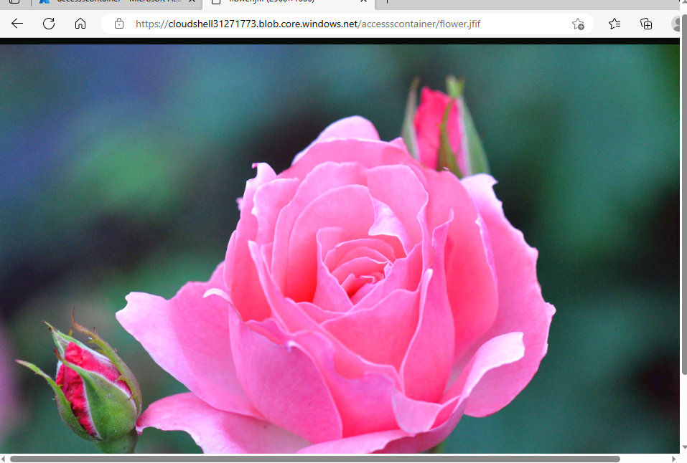

# **TASK 6:**

**Read-only Lock:**

A read-only lock prevents unintended modifications to a resource while allowing users to still view and read its contents. When a read-only lock is applied to a resource, it indicates that no changes can be made to the resource's settings or properties. The lock serves as a safeguard against alterations that could potentially affect the resource's state. Users retain the ability to access and retrieve information about the resource, including its attributes, status, and associated data. However, they are limited to performing read actions, such as accessing the resource's data or executing queries.

**Delete Lock:**

A delete lock provides an additional layer of security by preventing unauthorized or accidental deletion of a resource. When a delete lock is enforced on a resource, it disallows the removal of the resource itself. This lock is particularly useful for safeguarding critical or sensitive resources that should not be deleted or transferred. If a delete lock is in place, any attempt to delete the resource will be blocked. This protects against malicious or unintentional deletions that could result in the loss of valuable information or resources. However, users can still perform other activities on the resource, such as modifying its settings or properties, as long as deletion is not involved.

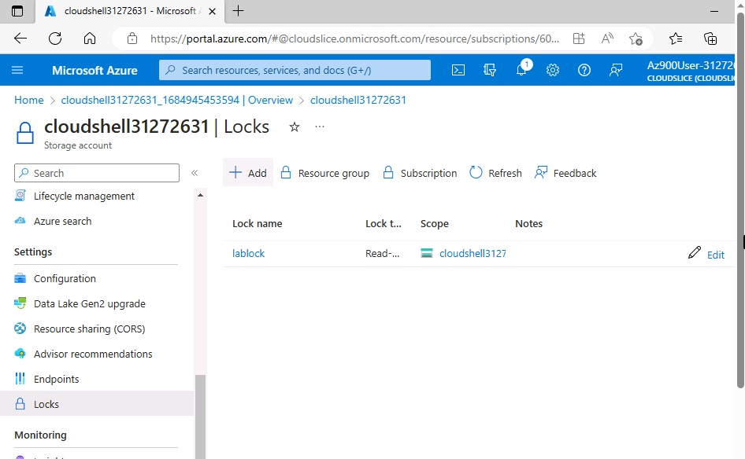

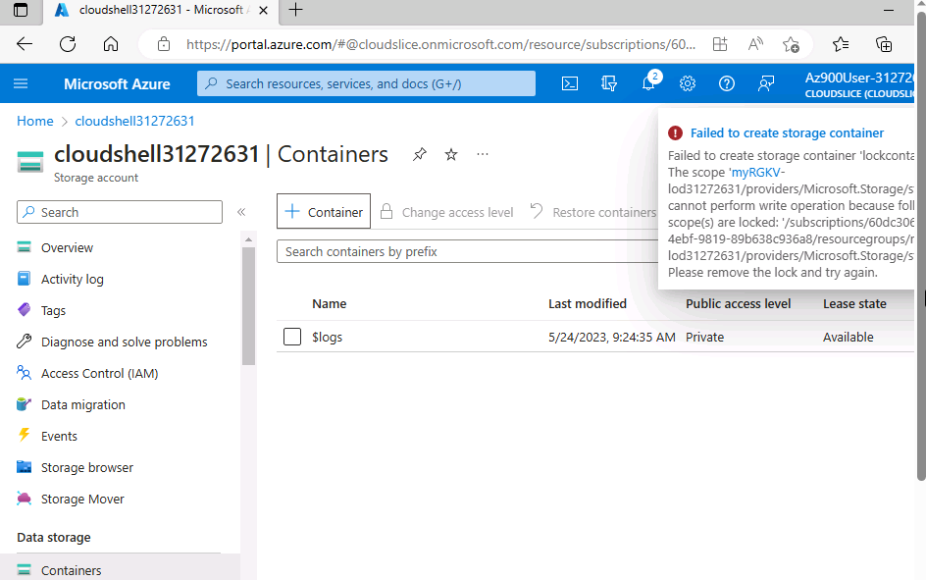

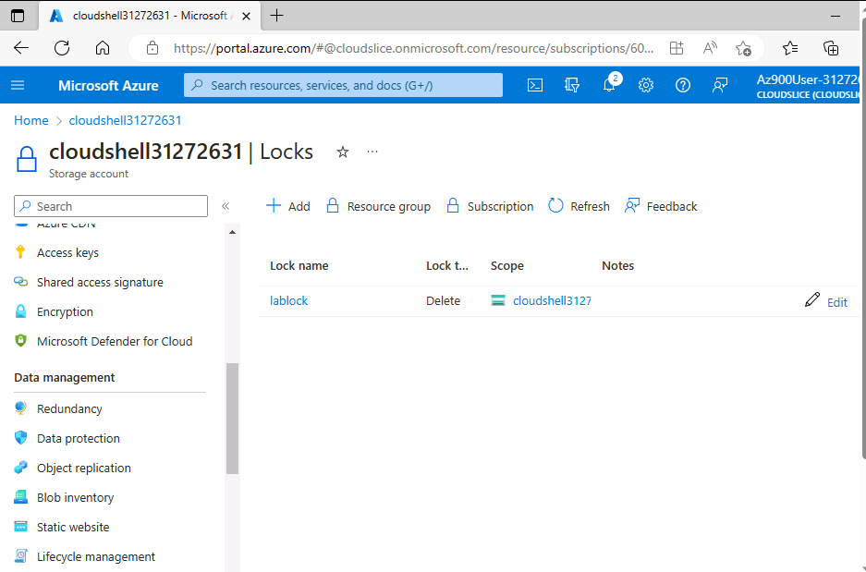

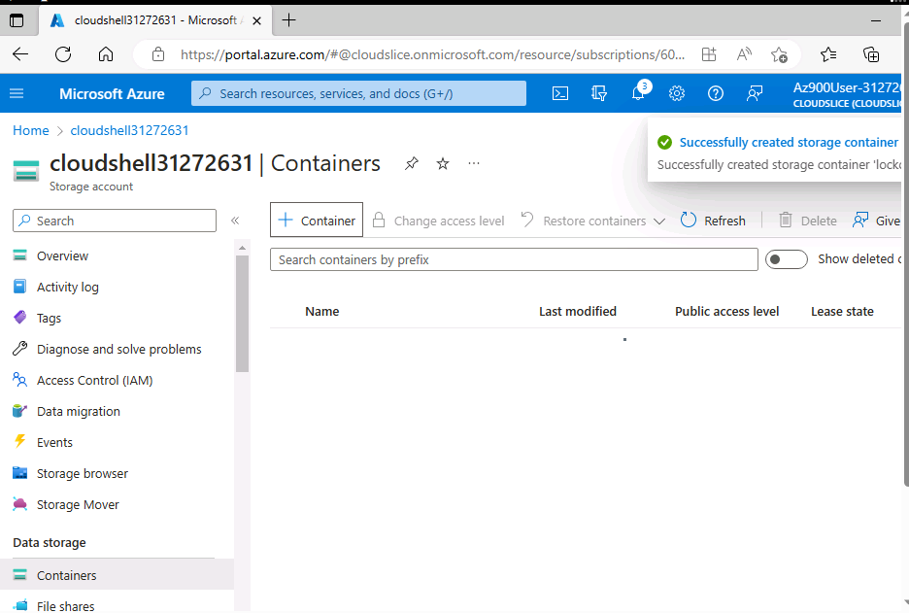

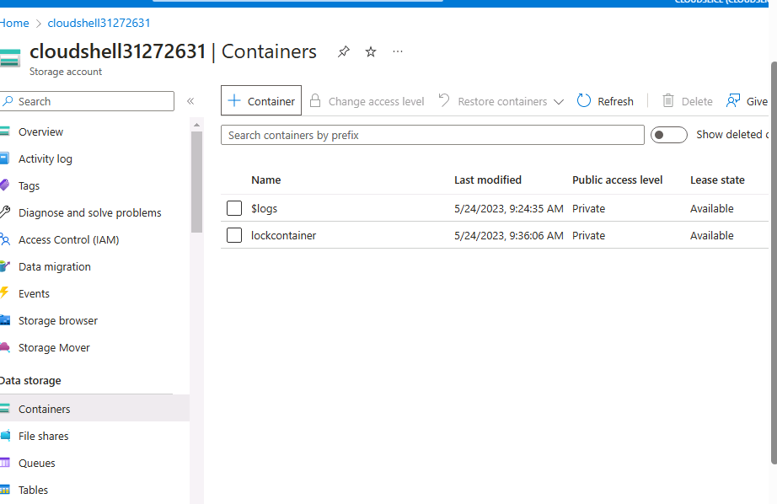

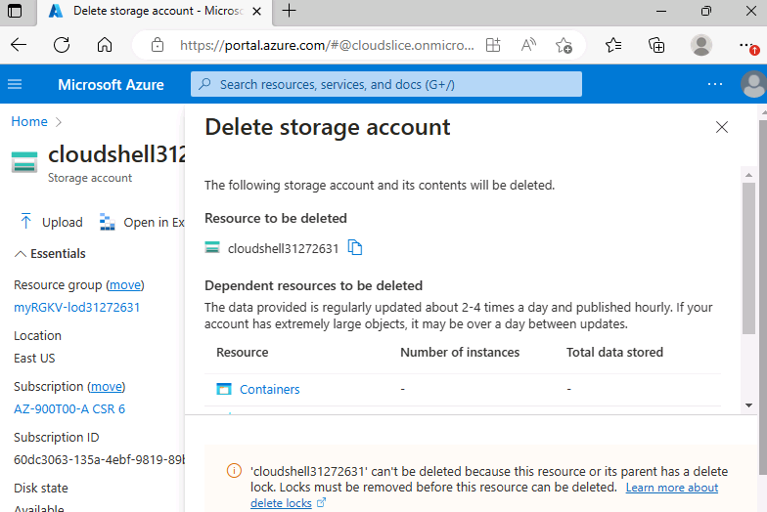

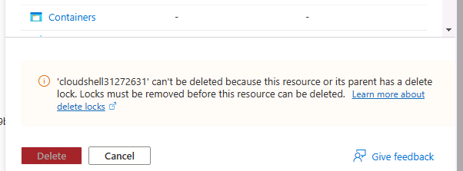



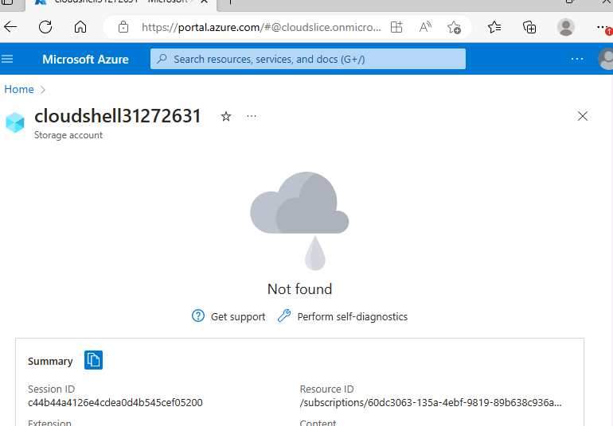

# 

# 

# **TASK 7:**

Here are some general factors to consider when evaluating the prices and features of a consumer desktop PC, server, and cloud virtual machine (Azure VM):

**Consumer Desktop PC:**

**Specifications:** The specifications of a consumer desktop PC can vary based on individual preferences and needs. A typical configuration for comparison might include an AMD Ryzen 5 or Intel Core i5 CPU, 8 GB or 16 GB of RAM, a 256 GB SSD for storage, and Windows 10 as the operating system.

**Cost**: The price of a consumer desktop PC can vary depending on the brand, configuration, and any additional components. A mid-range consumer desktop PC can be purchased for around $600 to $1,200, depending on the specific requirements and features.

**Server:**

**Specifications:** Servers are designed to handle larger workloads and are typically more powerful than consumer desktop PCs. A comparable server setup may include two AMD EPYC or Intel Xeon CPUs, expandable 32 GB or 64 GB of RAM, multiple hard disks or SSDs in a RAID setup for storage, and either Linux or Windows Server as the operating system.

**Cost:** The price of a server can vary widely based on the brand, specifications, and additional features. Generally, server prices range from $1,500 to $3,000 or more, depending on the performance level and inclusion of enterprise-grade components.

**Cloud Virtual Machine (Azure VM):**

**Details**: Azure VMs offer flexibility in choosing the desired configuration. A typical Azure VM setup might include a Standard_DS2_v2 instance with 2 virtual CPUs, 8 GB of RAM, a 100 GB SSD for storage, and the choice of Windows or Linux as the operating system.

**Cost**: The cost of an Azure VM depends on usage, region, and the selected instance type. Pricing is typically calculated on a pay-as-you-go basis, with hourly rates. Currently, a Standard_DS2_v2 Azure VM costs approximately $0.14 per hour or $103 per month.

**Trade-Offs:**

**Upfront Costs:** Consumer desktop PCs generally have lower upfront costs, while servers and cloud VMs may require larger initial investments due to their more powerful hardware and infrastructure requirements.

**Scalability:** Cloud VMs offer easy scalability, allowing resource modifications as needed. On-premises systems may require additional expenses for hardware upgrades or the acquisition of additional servers to achieve scalability.

**Maintenance and Management:** Consumer desktop PCs and on-premises servers require maintenance and management by the owner or organization. Cloud VMs handle infrastructure administration and upkeep through the cloud service provider.

**Flexibility and Mobility:** Cloud VMs offer more freedom and mobility as they can be accessed from any location with an internet connection. On-premises solutions are limited by their physical location.

**Cost Predictability:** On-premises solutions have fixed upfront costs, while cloud VMs follow a pay-as-you-go pricing structure, allowing for better cost control. However, on-premises solutions may be more cost-effective in the long run.

It's important to note that the above details and costs are approximations and can vary based on specific requirements, market conditions, and technological advancements. Consider individual needs, financial constraints, scalability requirements, and long-term cost projections when making a decision.